**COAL LAB 4**

**Question 1**

INCLUDE Irvine32.inc

.data

val1 SDWORD 8000

.code

main PROC

MOV eax, val1

ADD eax, 1

call dumpregs

exit

main ENDP

end main

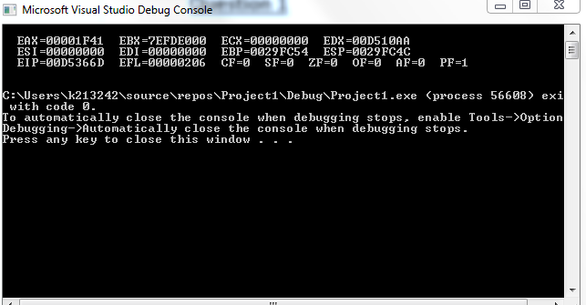

Carry flag is 0 because the addition produced no carry in the MSB and the sign flag is 0 as the result is a positive integer.

**Question 2**

1. CF = 1, SF = 0, ZF = 1, OF = 0
2. CF = 0, SF = 1, ZF = 0, OF = 1
3. CF = 0, SF = 1, ZF = 0, OF = 0

**Question 3**

Include Irvine32.inc

.data

arr DWORD 8, 5, 1, 2, 6

.code

Main PROC

MOV esi, OFFSET arr

MOV eax, DWORD ptr 0

MOV edx, DWORD ptr 0

MOV eax, [esi]

MOV ebx, [esi+16]

MOV [esi+16], eax

MOV eax, [esi+8]

MOV [esi], eax

MOV eax, [esi+4]

MOV edx, [esi+12]

MOV [esi+4], edx

MOV [esi+8], eax

MOV [esi+12], ebx

MOV eax, [esi+8]

call dumpregs

exit

main endp

end main

**Question 4**

Include Irvine32.inc

.data

arrayB BYTE 10, 20, 30

arrayW WORD 150, 250, 350

arrayD DWORD 600, 1200, 1800

SUM1 DWORD ?

SUM2 DWORD ?

SUM3 DWORD ?

.code

main PROC

MOVZX eax, arrayB

ADD SUM1, eax

MOVZX eax, arrayW

ADD SUM1, eax

MOV eax, arrayD

ADD SUM1, eax

MOVZX eax, arrayB[1]

ADD SUM2, eax

MOVZX eax, arrayW[2]

ADD SUM2, eax

MOV eax, arrayD[4]

ADD SUM2, eax

MOVZX eax, arrayB[2]

ADD SUM3, eax

MOVZX eax, arrayW[4]

ADD SUM3, eax

MOV eax, arrayD[8]

ADD SUM3, eax

MOV eax, SUM1

MOV ebx, SUM2

MOV ecx, SUM3

call dumpregs

exit

main endp

end main

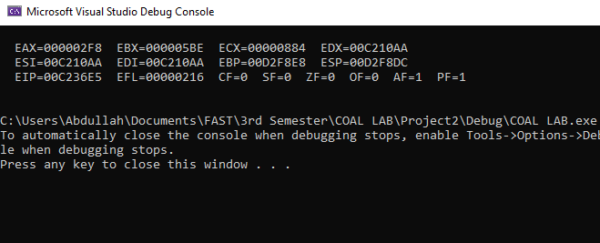

**Question 5**

Include Irvine32.inc

.data

array1 BYTE 10, 20, 30, 40

array2 BYTE 4 dup(?)

.code

main PROC

MOV eax, DWORD ptr 0

MOV al, array1[3]

MOV array2, al

MOV al, array1[2]

MOV array2[1], al

MOV al, array1[2]

MOV array2[2], al

MOV al, array1

MOV array2[3], al

MOVZX eax, array2

call dumpregs

exit

main endp

end main

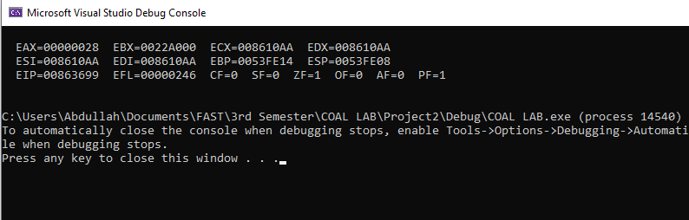

**Question 6**

Include irvine32.inc

.data

arr1 DWORD 5, 6, 7, 8, 9

arr2 DWORD 10, 12, 14, 15, 19

.code

main PROC

MOV esi, arr1

MOV edi, arr2

MOV eax, [esi]

SUB [edi], eax

ADD esi, 4

ADD edi, 4

MOV eax, [esi]

SUB [edi], eax

ADD esi, 4

ADD edi, 4

MOV eax, [esi]

SUB [edi], eax

ADD esi, 4

ADD edi, 4

MOV eax, [esi]

SUB [edi], eax

ADD esi, 4

ADD edi, 4

MOV eax, [esi]

SUB [edi], eax

exit

main endp

end main

**Question 7**

Include Irvine32.inc

.data

arrayB BYTE 60, 70, 80

arrayW WORD 150, 250, 350

arrayD DWORD 600, 1200, 1800

.code

main PROC

MOV eax, DWORD ptr 0

MOV ebx, DWORD ptr 0

MOV edx, DWORD ptr 0

ADD al, arrayB

ADD al, arrayB+2

ADD bx, arrayW

ADD bx, arrayW+4

ADD edx, arrayD

ADD edx, arrayD+8

Call DumpRegs

exit

main endp

end main

